**In class exercises Ch.6**

1. Naïve Bayes classification example. Consider new instance

**<Outlook=sun, Temp=cool, Humid=high, Wind=strong>**

Use NB to classify it: ‘yes’ or ‘no’.

How many classes are there? ____________

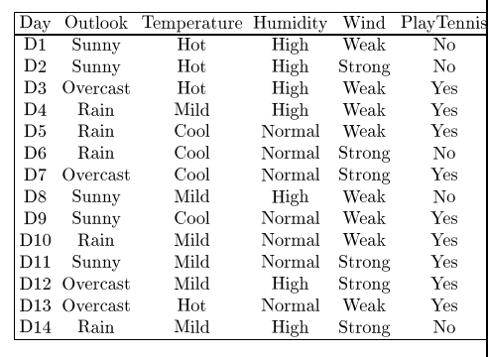­

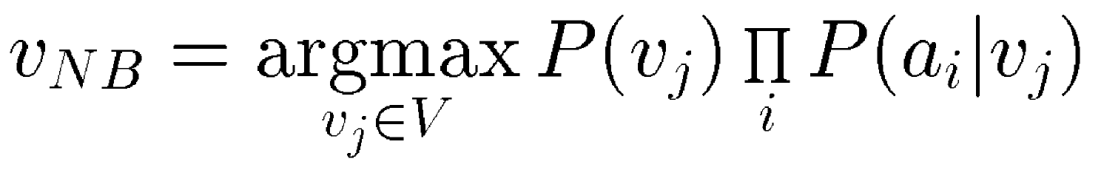

|  |  |
| --- | --- |
| P(yes) = | P(no) = |
| P(a1=sun|yes)=  P(a2=cool|yes)=  P(a3=high|yes)=  P(a4= strong|yes)= | P(a1=sun|no)=  P(a2=cool|no)=  P(a3=high|no)=  P(a4=strong|no)= |