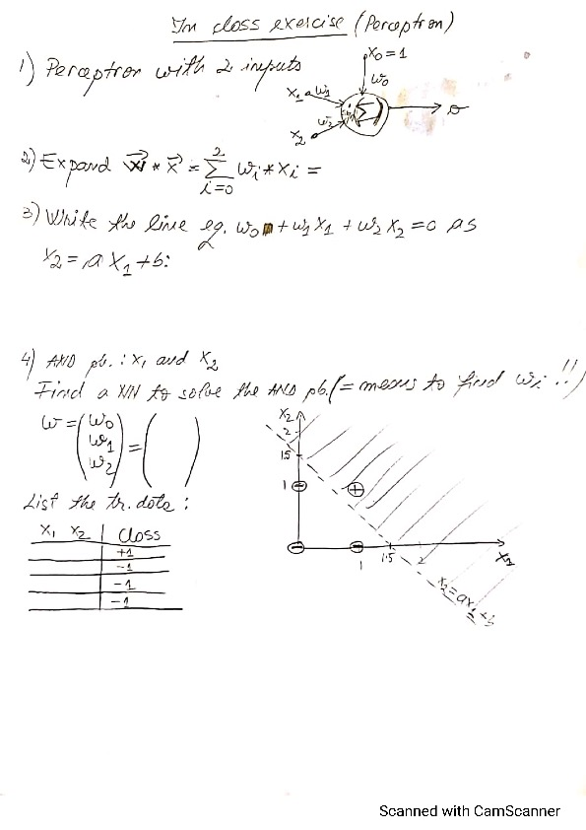

**Why do we need bias x0 in the perceptron?** The same reason we need bias b in equation of a line x2=a*x1+b. Namely, to be able to draw lines that cross the two axes, NOT only lines that go through origin (those lines of equation x2=a*x1 have no bias).

