# Lab 2: Bits and Bytes (10 points)

For this assignment you will encode the word “ACE” into binary. Keep in mind all capital letters!

Use this ASCII table for reference:

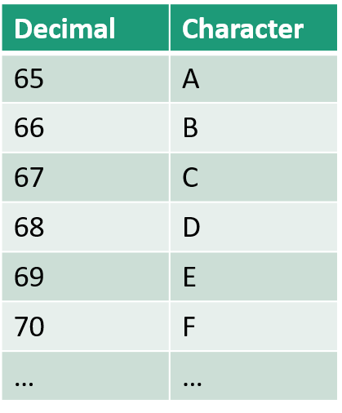

|  |  |  |  |  |  |  |  |
| --- | --- | --- | --- | --- | --- | --- | --- |
| 27 | 26 | 25 | 24 | 23 | 22 | 21 | 20 |
|  |  |  |  |  |  |  |  |

A = ???

+ + + + + + +

= ???

|  |  |  |  |  |  |  |  |
| --- | --- | --- | --- | --- | --- | --- | --- |
| 27 | 26 | 25 | 24 | 23 | 22 | 21 | 20 |
|  |  |  |  |  |  |  |  |

C = ???

+ + + + + + +

= ???

|  |  |  |  |  |  |  |  |
| --- | --- | --- | --- | --- | --- | --- | --- |
| 27 | 26 | 25 | 24 | 23 | 22 | 21 | 20 |
|  |  |  |  |  |  |  |  |

E = ???

+ + + + + + +

= ???