Finite State Machines (FSMs)
NAME:

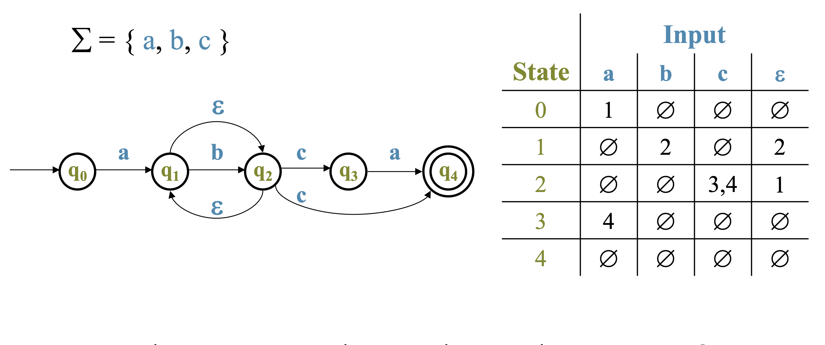
- What regular expression corresponds to the NFA above?

[2 pts] ANSWER:

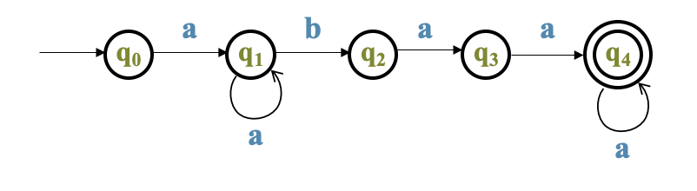

- What regular expression corresponds to the NFA above?

[2 pts] ANSWER:

What regular expression corresponds to the DFA to the right?
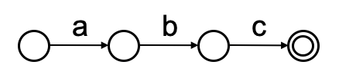
[2 pts] ANSWER:

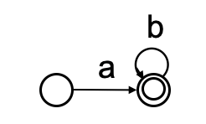

[2 pts] ANSWER:

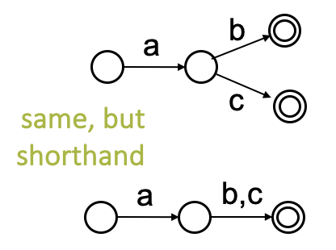

[2 pts] ANSWER:

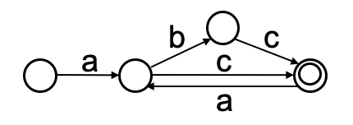

[2 pts] ANSWER:

Provide a NFA for the following:
S ε
S xX
S yY
Y yY
Y ε
X xX
X ε

Here some shapes you can copy/paste to help you get started.
x,y

[3 pts] ANSWER:

