Syllabus: CS 100 Scientific Computing - Fall 2021
Class Time: | MWF 10 – 10:50 am in Taylor 205
Website: | http://csweb.wooster.edu/hguarnera/cs100/
Professor: | Heather Guarnera (hguarnera@wooster.edu)
Office: | Taylor 303
Office Hours: | TBA
Zone Intern: | El Yazid Chalabi
Teaching Assistant: | Mary Payne
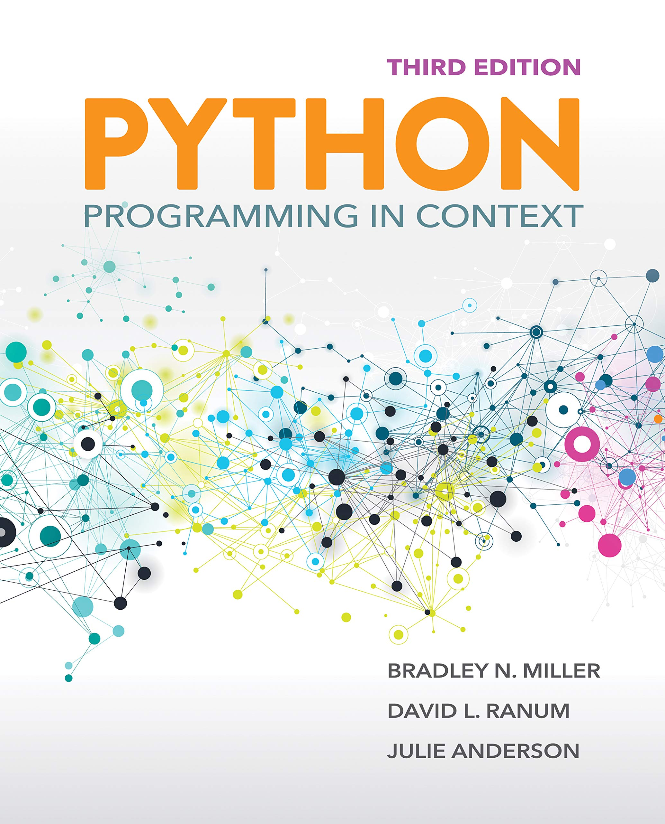
Textbook: Python Programming in Context, 3rd Edition, B. N. Miller, D. L. Ranum, Jones & Bartlett
Learning (ISBN: 9781284175554). A few copies are available on OhioLink; the second edition is available on Safari Online.

Course Description: The purpose of this course is to show some of the connections between computer science and other disciplines such as mathematics and the natural sciences. We will study the fundamental computer science concepts for the design and implementation of solutions to problems that can be solved through approximations, simulations, interpolations, and recursive formulas. Course material includes Python programming for
- plotting functions and data
- approximating Pi using various methods
- encryption and cipher algorithms
- computing statistics with large datasets
- processing digital image and manipulating image files
- clustering analysis
- creating simulations to model more complex behavior (e.g. simulate predator-prey relationships; use fractals to simulate trees and snowflakes)
This is a hands-on course where students work in multidisciplinary groups to design and implement several small and medium scale projects.

Prerequisite: No prerequisite. Offered annually, fall and spring [MNS].

Grading: Your final grade will be calculated as follows.
10% | Reading quizzes. There will be a total of ~18 short quizzes (roughly 5-8 questions) that will be available on Moodle. I will take your grade based on the best out of 15. Quizzes are open-book and open-notes, but they are timed, so I suggest you create notes for quick reference. It is important that you complete the assigned reading before class starts on the due date, as we will begin solving problems in Python during class time with those concepts. There are no makeup quizzes.
15% | Participation. I encourage you to actively and respectfully participate. You will have many opportunities to do so: primarily through successful completion of programming assignments started during class, as well as asking and answering questions, attending the STEM Zone, and Scientist Spotlight.
25% | Homework. Regular assignments which are primarily based on writing code to solve various problems. Typically due every Friday before class, unless otherwise stated.
20% | Exam 1. See schedule for tentative time
20% | Exam 2. See schedule for tentative time
10% | Final project. A collaborative (teams of 2-3 students) programming assignment designed to solve a selected problem. At the end of the semester, your team will give a presentation and demonstration of your final project.

A | A- | B+ | B | B- | C+ | C | C- | D | F
93% | 90% | 87% | 83% | 80% | 77% | 73% | 70% | 60% | below
This class uses the standard grading scale:

Note that the main purpose of in-class activities and homework assignments is to give students opportunities to practice what they learn. It is expected that much of your learning will come from practice! I hope that you understand the value of this work, and do not regard it solely as a grading source. With this in mind, the instructor will choose to grade only a subset of in-class activities and labs. The remaining subset could be graded partially or based on whether the work was submitted.

Pass/Fail option. Students are permitted to elect the equivalent of four courses (in addition to Senior Independent Study) graded S/NC out of 32 courses required for graduation [excluding courses taken S/NC in Spring 2020, Fall 2020, and Spring 2021]. The minimum equivalent grade to earn S in courses graded S/NC is C-. The deadline for electing a Pass-Fail grading option is one week after final grades are posted.

Course Drop. The College is temporarily extending the deadline for dropping a course. Students may drop any course by Friday, December 10. The minimum enrollment of 3.0 credits remains in effect. Requests to drop enrollment below 3.0 credits will require additional documentation via Other academic petitions.

Attendance: We work best as a learning community when everyone participates. As such, it is expected that you will attend class at scheduled times and in accordance with health and safety protocols. If you are unable to attend, I encourage you to check the course website and get notes from a classmate to catch up on missed materials. I will communicate to you in a timely manner any changes to this schedule.

Technology: Our class works best when we use our devices to further our learning. I encourage you to only use technology during class time to enable, rather than to distract from, our learning and community building. During class, we’ll write code. Bring your laptop to every day.

Recording of Classes: On occasion, I may plan to record class discussions for educational purposes. Recordings will be available only to course participants on password-protected websites. No one should distribute recordings, screenshots, or other course material beyond class without express permission of all involved in the recording. I will inform those participating, and offer options for participation to protect student privacy.

Communication: Communication is the key to success. Contact me as soon as possible if you are struggling with material or if a conflict arises. The best way to contact me outside of class by coming to my office hours. It is so often the case that when one student has a question, several others have the same or similar question. We use Piazza so that the entire class can collectively benefit from questions, and so that your classmates can see that they are not alone in their struggle. I encourage you to share your understanding with your classmates by answering questions as well; you will earn participation points by doing so. If you have a private concern, such as a question about your grade, we can discuss it in a private setting.
You should allow at least 24 hours response time for any communication. I usually respond faster than that, but you should not count on it. Please keep this in mind when contacting me late at night or over the weekend.

Late Policy: I will do my best to grade and return assignments to you as soon as I can. Late submissions make timely grading much more difficult. As such, late homework assignments will be subject to a 25% penalty if it is up to 8 hours late, and a 50% penalty if it is up to 24 hours late. No late assignments are accepted after 24 hours.

Accommodations: Your success in this class is important to me. We all need accommodations to learn effectively. If there are aspects of this course that prevent you from learning or exclude you, please let me know as soon as possible. You do not need to share specifics, but we can work together to develop strategies to meet both your needs and the requirements of the course, and to identify specific resources that may assist you.
This Photo by Unknown Author is licensed under CC BY-SA

Names and Pronouns. All people have the right to be addressed and referred to in accordance with their personal identity. We include pronoun introductions to avoid gender-based assumptions and to ensure that the correct pronoun is used when referring to you. I will do my best to address and refer to all students by the names and pronouns shared in class, regardless of what is listed on the roster, and I support classmates doing so as well.
In this class, we will have the chance to indicate the name that you would like to be called and, if we choose, to identify pronouns with which we would like to be addressed. The name and pronoun(s) that you use may change and, if they do, please let us know you would like us to change how we address you. If you are interested in changing your chosen name and pronoun(s) in the College of Wooster system, you can find additional information here.

Academic Honesty: You are expected to know and abide by the rules of the institution as described in The Scot’s Key and the Handbook of Selected College Policies (found here). Dishonesty in any of your academic work is a serious breach of the Code of Academic Integrity and is grounds for an F in this course. Such violations include turning in another person’s work as your own, copying from any source without proper citation, and violating expectations for a group project.

Conflicts with Academic Responsibilities: When conflicts arise between academic commitments and complementary programs (including athletic, cultural, educational, and volunteer activities), students, faculty, staff, and administrators all share the responsibility of minimizing and resolving them. The College expects students to give the highest priority to their academic responsibilities. As a student you have the responsibility to inform me of potential conflicts as soon as you are aware of them, and to discuss and work with me to identify alternative ways to fulfill your academic commitments without sacrificing the academic integrity and rigor of the course.

Title IX: The College is committed to fostering a campus community based on respect and nonviolence. To this end, we recognize that all Wooster community members are responsible for ensuring that our community is free from discrimination, gender bias, sexual harassment, and sexual assault. In accordance with Title IX, Wooster is legally obligated to investigate incidents of sexual harassment and sexual assault that occur on our campus. Faculty who become aware of an incident of sexual violence, including harassment, rape, sexual assault, relationship violence, or stalking, are required by law to notify Wooster’s Title IX Coordinator. The purpose of this disclosure is to ensure that students are made aware of their reporting options and resources for support. For more information about your rights and reporting options at Wooster, including confidential and anonymous reporting options, please visit here.

MCS Department: The College of Wooster is committed to inclusive excellence in undergraduate education, and our department seeks to actively foster a welcoming learning environment in which diversity and individual differences are valued, respected, and celebrated. Diversity comes in many forms, including but not limited to, race, color, national origin, ancestry, sex, gender identity and expression, sexual orientation, socioeconomic status, religion, age, and physical and/or mental abilities. The diversity that students and staff bring to the classroom is an invaluable resource, strength, and benefit to everyone at the College of Wooster. As such, we are vigilant and attentive about issues of diversity, equity, and inclusion in the classroom. Expressions or actions disparaging others are contrary to the mission of the department and will not be tolerated.

Additional Resources. Please view the course website for additional links and resources, including information on Moodle, the Academic Resource Center, Library Support, health and safety guidelines, Title IX, and discriminatory or bias-related harassment reporting. Once finished, share on Piazza a picture of your favorite animal. Create a new thread called “Read the syllabus” if necessary, or use an existing thread if someone already posted.

