HW 1 (10 pts)
Name: YourName

Write your solution after the question. Show your work (i.e., the relevant python code). An example question has already been filled out for you. Submit this file to Moodle.

- [0 pt] Compute the sum of 8, 9, and 10.
>>> 8 + 9 + 10
27

- [1/2 pt] Compute the number of seconds in a year.

- [1/2 pt] Compute the number of inches in 1 mile

- [1 pt] Compute the number of 3 ft square tiles to cover the floor of a 9 by 12 ft room.

- [1 pt] Compute the number of handshakes required for each person in a class of 19 to shake hands with all other classmates.

- [1/2 pt] Compute 1/3 of 45.

- [1 pt] The Andromeda galaxy is 2.9 million light years away. There are $5.879 ⋅{10}^{12}$ miles per light year. How many miles away is the Andromeda galaxy?

- [1 pt] How many years would it take to travel to the Andromeda galaxy at 65 miles per hour?

- [1 pt] Compute the factorial of 11.

- [1/2 pt] Which of the following are legal variable names?
  - _abcd123
  - 123abc_
  - abc123_
  - _123

- [1 pt] Draw a reference diagram to show the labels and objects after evaluating all statements.
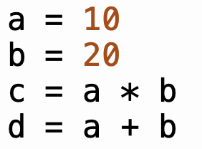

- [1 pt] What are the values of a and b after Python evaluates each of the following four statements?
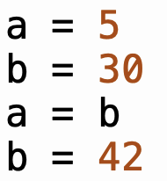

- [1 pt] What is the value of idx after Python evaluates all of the following statements?
