EX03 Worksheet (10 pts)
Name: YourName

Write your solution after the question. Show your work (i.e., the relevant python code). An example question has already been filled out for you. Submit this file to Moodle.

- [0 pt] Compute the sum of 8, 9, and 10.
>>> 8 + 9 + 10
27

- [1/2 pt] Compute the number of seconds in 2 years.

- [1/2 pt] Compute the number of inches in 3 miles.

- [1 pt] Compute the number of 3 ft square tiles to cover the floor of a 12 by 12 ft room.

- [1/2 pt] Compute 1/3 of 36.

- [1 pt] The Andromeda galaxy is 2.9 million light years away. There are $5.879 ⋅{10}^{12}$ miles per light year. How many miles away is the Andromeda galaxy?

- [1 pt] How many years would it take to travel to the Andromeda galaxy at 35 miles per hour?

- [1 pt] Convert the decimal number 126 to binary.

- [1 pt] Convert the binary number 1001101 to decimal.

- [1/2 pt] Which of the following are legal variable names? Write your answer below.
abc123_
123abc_
_abcd123
_123

- [1 pt] After all lines are evaluated, what are the values of a, b, c, and d? Label each variable name with its value.
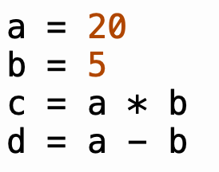

- [1 pt] What are the values of a and b after Python evaluates each of the following four statements?
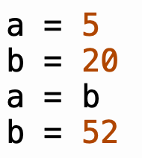

- [1 pt] What is the value of idx after Python evaluates all of the following statements?
