CSCI 23000W Software Engineering Fall 2022 8/24/2022

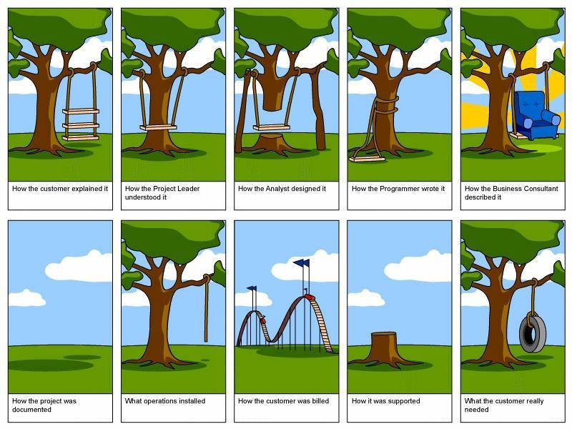

Instructor
Dan Palmer Office: Taylor 310 Phone: 287-1981 E-mail: danpalmer@wooster.edu

Office Hours: Mondays and Fridays 1:00pm – 3:00pm, Wednesdays 2:00pm – 4:00pm

Meeting Times and Location
MWF 10:00am - 10:50am Taylor 302

Textbooks and Resources
The textbooks are all available freely online through O’Reilly. You can buy a physical copy if you like, but it is not required. See the course web page for links to the books. Wooster has access to O’Reilly’s digital library, and you can get access through your Scotweb credentials at this website here .
- Head First Software Development by Dan Pilone and Russ Miles
- The Mythical Man-Month: Essays on Software Engineering, Anniversary Edition, by Frederick Brooks Jr.
- Code Complete, Second Edition by Steve McConnell

Communication
Check email multiple times per day – Check the course Moodle site for materials and notifications. You are responsible for any messages that get sent to students.

Course Description: This course introduces students to the field of software engineering, a discipline concerned with the application of theory, knowledge, and practice to effectively and efficiently build reliable and maintainable software systems that satisfy the requirements of stakeholders. An additional focus of the course is on developing skills that will enable students to communicate technical and non-technical information about computer science.
Writing Intensive Course: The “W” at the end of the course number means that this is a writing intensive course. As such, there will be writing specific requirements and assignments. Some of the writing on this course deals with ethical issues. Each student is required to take and successfully complete one writing intensive course any time after completing an FYS course and before the beginning of the Junior Independent Study course. What does it mean for a course to be writing intensive? The following set of criteria is paraphrased from the official description:
Writing-intensive courses will focus on the process of writing as a means of learning and effective communication within a specific content area and the writing will be integrated with other class work. Each course will require five to six formal writing assignments of 800-1000 words each (or, for the semester's work, a comparable number of total pages). At least three of the formal assignments must go through a revision process, with drafts to be reviewed by the instructor, peers, and other readers. The editing process must address deeper issues than just spelling and grammar.
With this in mind, we will have many readings and writing assignments, so come to this class prepared to write and plan on visiting the Writing Center (for at least one assignment that will be a requirement).
Prerequisite: CSCI 12000 with minimum grade C-
Course Goals: Upon completion of this course, a successful student will be able to:
- Apply select software development process models
- Design and implement a software application of moderate complexity within a team
- Articulate in writing ethical challenges in the field of computing
- Apply effective written communication within the discipline
- Compose:
  - a development plan for a software project
  - project specifications
  - software design and user documentation
  - an analysis of published work in the field of computer science

Assessment of Progress
The students’ progress towards these goals will be assessed through targeted programming assignments and exam questions related to the learning goals.

A | A- | B+ | B | B- | C+ | C | C- | D | F
93% | 90% | 87% | 83% | 80% | 77% | 73% | 70% | 60% | below
This class uses the
standard grading scale:

Pass/Fail Option Students are permitted to elect the equivalent of four courses (in addition to Senior Independent Study) graded S/NC out of 32 courses required for graduation [excluding courses taken S/NC in Spring 2020, Fall 2020, and Spring 2021]. The minimum equivalent grade to earn S in courses graded S/NC is C-. The deadline for electing a Pass-Fail grading option is one week after final grades are posted.

Course Drop
Students may withdraw from a course after the 6th-week drop deadline until the last day of classes (Friday, December 9, 2022). Students may withdraw from one course, up to 1.25 credits, at any time through the last day of classes, as long as their total remaining credits are 3.0 or above. This may be done without documentation of extenuating circumstances. Requests to drop enrollment below 3.0 credits will require additional documentation through a Petition for an Exception to an Academic Policy.
Note that because federal government guidelines define courses as ‘attempted’ after 6 weeks, if a student withdraws from a course after 6 weeks, it will be noted as a ‘W’ on their transcript.

Semester-long Projects
Depending on the total number of people in the class, we will have several teams of students working on several different projects. Throughout the semester, we will mix up the teams and the projects so that every student will work on every project, and with most other students in the class. To illustrate the software development process, students will work in teams on the many different stages of a software development process: Requirements analysis, Design, Implementation, and Testing. A student that works of the requirements for a project, will not do the design or implementation for that project, and so on.

Grading of Projects
A key aspect of this class is to learn the stages of software development by doing them. It is not reasonable to expect that you will do well on your first attempt as these practices. After you finish a stage of this process, you will assuredly feel that you could do a much better job if you were to do it over again. This is one of the goals of this course! In light of this, and to encourage courageous attempts, the stages of this project will be graded on participation, effort, teamwork, feedback to other teams, following of procedures, and knowledge of processes, not necessarily the resulting project.

Participation
The central component of this course is learning teamwork. You cannot learn this when you are not in class. Attendance for this course is required. You must be here every class unless you are ill or have an excused absence. Missing too many classes will be very detrimental to your learning experience. Please contact me if you are sick or are going to miss class for any other reason.

Late Policies:
Due to COVID-19 and the desire encourage students to stay healthy and care for themselves when they are not, if you cannot turn in an assignment because you are not feeling well, contact me before the due date with an information regarding your situation. I will determine how to proceed on a case-by-case basis. In some cases, it may require a different assignment be done. I will do my best to grade and return writing/homework assignments to you as soon as I can. Late submissions make timely grading much more difficult. As such, late assignments will be subject to a 15% penalty if it is up to 8 hours late, and a 25% penalty if it is up to 24 hours late. If you have extenuating circumstances, contact me BEFORE the assignment is due to discuss how to proceed.

Final Exam
There is no final exam for this class. We WILL NOT meet during final exam week.

Requirements
Your final grade will be calculated as follows:
30% Homework Assignments: Written and Programming
30% Midterms (2 exams 15% each)
40% Semester-long Project (Req., Design, Implementation, Testing)

Schedule
Please see course website for more details of the schedule during the semester. The schedule below is a general one and subject to change. NOTE: This schedule shows only the portions of the course related to the project development process. See the detailed schedule for the writing components.

Week |  | Topic
1 | 8/24 | Introduction
1-2 | 8/26 – 9/7 | Requirements Analysis
3-4 | 9/9 – 9/21 | Software Design
5 | 9/28 | Midterm Exam 1
6 | 9/30 – 10/7 | Test Development
 | 10/9 – 10/16 | Fall Break
7-10 | 10/17 – 11/4 | Implementation
11-12 | 11/7 – 11/18 | Software Testing
13 | 11/21 | Midterm Exam 2
14 | 11/28 – 12/2 | Software Testing
15 | 12/5 – 12/9 | Project Post-Mortem Discussion

Attendance: We work best as a learning community when everyone participates. As such, it is expected that you will attend class at scheduled times and in accordance with health and safety protocols. If you are unable to attend, I encourage you to check the course website and get notes from a classmate to catch up on missed materials. I will communicate to you in a timely manner any changes to this schedule. Note: If you are not feeling well, please care for yourself, stay home, and reach out for course materials and help.

Technology: Our class works best when we use our devices to further our learning. Plan to use technology during class time to enable, rather than to distract from, our learning and community building. Bring your laptop to every day.

Communication: Communication is the key to success. Contact me as soon as possible if you are struggling with material or if a conflict arises. The best way to contact me outside of class by coming to my office hours or via email (danpalmer@wooster.edu). It is so often the case that when one student has a question, several others have the same or similar question. Use the class Teams Q&A channel so that the entire class can collectively benefit from questions, and so that your classmates can see that they are not alone in their struggle. Please feel free to share your understanding with your classmates by answering questions as well; you may earn participation points by doing so. If you have a private concern, such as a question about your grade, we can discuss it via email or in a private setting.

Accommodations: Your success in this class is important. We all need accommodations to learn effectively. If there are aspects of this course that prevent you from learning or exclude you, please let me know as soon as possible. You do not need to share specifics, but we can work together to develop strategies to meet both your needs and the requirements of the course, and to identify specific resources that may assist you.

Names and Pronouns. All people have the right to be addressed and referred to in accordance with their personal identity. I will do my best to address and refer to all students by the names and pronouns shared in class, you may wish to include a include a phonetic spelling. and I support classmates doing so as well. If you are interested in changing your chosen name and pronoun(s) in the College of Wooster system, you can find additional information here.

Honesty & Academic Integrity / Student Rights: You are expected to know and abide by the rules of the institution as described in The Scot’s Key and the Handbook of Selected College Policies (found here: The Scot’s Key).

Conflicts with Academic Responsibilities: When conflicts arise between academic commitments and complementary programs (including athletic, cultural, educational, and volunteer activities), students, faculty, staff, and administrators all share the responsibility of minimizing and resolving them. The College expects students to give the highest priority to their academic responsibilities. As a student you have the responsibility to inform me of potential conflicts as soon as you are aware of them, and to discuss and work with me to identify alternative ways to fulfill your academic commitments without sacrificing the academic integrity and rigor of the course.

MCS Department: The College of Wooster is committed to inclusive excellence in undergraduate education, and our department seeks to actively foster a welcoming learning environment in which diversity and individual differences are valued, respected, and celebrated. Diversity comes in many forms, including but not limited to, race, color, national origin, ancestry, sex, gender identity and expression, sexual orientation, socioeconomic status, religion, age, and physical and/or mental abilities. The diversity that students and staff bring to the classroom is an invaluable resource, strength, and benefit to everyone at the College of Wooster. As such, we are vigilant and attentive about issues of diversity, equity, and inclusion in the classroom. Expressions or actions disparaging others are contrary to the mission of the department and will not be tolerated.

Additional Resources:

The College Libraries and the Research Help Desk
Contact: library@wooster.edu, 330-263-2493, Libraries website
Our librarian is Ian McCullough.

Academic Resource Center: Academic Support and Disabilities
Contact: Amber Larson, alarson@wooster.edu, (330)263-2595, ARC Website
The Academic Resource Center coordinates accommodations for students with diagnosed disabilities. At the beginning of the semester, students should contact the Academic Resource Center to make arrangements for securing appropriate accommodations. Although the Academic Resource Center will notify professors of students with documented disabilities and the approved accommodations, students are encouraged to speak with professors during the first week of each semester. If a student does not request accommodations or does not provide documentation to the Academic Resource Center, faculty are under no obligation to provide accommodations.

Title IX Reporting Policy Regarding Sexual Misconduct, Harassment, Relationship Violence, and Stalking
Contact: Joe Hall, jhall@wooster.edu, Title IX website

Discriminatory or Bias-Related Harassment Reporting Policy
Contact: Visit the Bias Reporting website

Wellbeing at Wooster
Contact (24/7): (330) 263-2319, or visit the Wellness Center website

Basic Needs, Food Security & Access to Course Materials
Contact: Dean of Students Office, dos@wooster.edu, 330-263-2545, Galpin Hall

We’re All Human
Let’s all practice empathy, kindness, and understanding - towards each other and ourselves.
Although every effort has been made to make this syllabus as complete as possible, changes may occur regarding the course schedule, grading, assignments, and office hours. I reserve the right to make changes to this syllabus if necessary. Any changes will be communicated in a timely manner.

“Education is the only product for which the consumer rejoices upon non-delivery”

